Architecture Diagram & Object Models

FH Mobile Application

Version 1.3

Prepared by

Omar Rivera
Andrew Poirier
Daven Amin
Rick Rejeleene
Withing the FH mobile application there are three parts; the client, database and server. The client and the server are described below in Figure 1.0. The database deign is described in ERD below in figure 1.1.

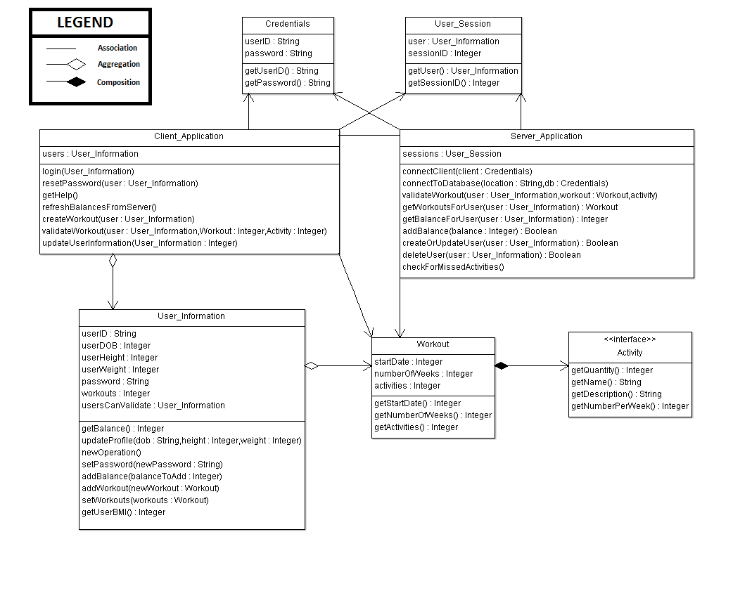

Figure 1.0 – Class Diagram for FH Mobile Application

In figure 1.0 there is a simulation of how the database for the Fitness Health application will be distributed. The database has five major tables in it's database. The high level table where all of the information is coming from is the User table. This table will be used to store all of the information that will be needed for the application to retrieve workout, bank, login and to calculate information. The way that the system is able to do it is through the userID field. This field is a public key, foreign key and a requirement for any data alteration. This userID will be used throughout the system as a way to store and retrieve information for a particular person.
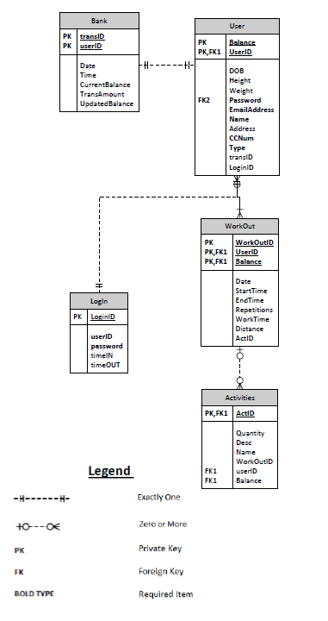
Figure 1.1 – Database Design

